Import Data using Transform Maps (Spreadsheet)

Phase-4 -- Project Planning Phase
 | Date | 28/09/2026
 | Team Id | SWTID-2026-8259
 | Project Name | Import Data using Transform Maps  (Spreadsheet)
 | Project Guide Name | Mr.S.Sakthikumar MCA.,M.Phil.
Team Leader :

- Nandhini R – nandhiniramu10@gmail.com

Team Members :

- Roshini K – roshini2007ro@gmail.com
- Santhi K – santhini1422007@gmail.com
- Santhiya C – c.santhiya7311@gmail.com



Define clear objectives to guide the implementation and verification steps:

- Import employee data from a spreadsheet into ServiceNow reliably.
- Use an Import Set as a staging area (u_employee_import).
- Use a Transform Map to map and move data into the Employee Test table (u_employee_test).
- Maintain Employee ID as the primary identifier and Coalesce key to prevent duplicates.
- Support both insert (new records) and update (existing records) operations.
- Validate transformed records and produce three reports and a centralized dashboard.

- Prepare the spreadsheet data before loading it into the ServiceNow Import Set.
- Create the Employee Import staging table to receive spreadsheet records.
- Create the Employee Test target table to store transformed employee records.
- Configure the Transform Map between the Employee Import and Employee Test tables.
- Map all five employee fields correctly during the transformation process.
- Use Auto Map Matching Fields where the source and target field names match.
- Use Mapping Assist for fields that require manual mapping.
- Test the transformation using new and existing Employee IDs.
- Verify the transformation results through Transform History and the Employee Test table.
- Provide employee data visibility through department, location, and employee-list reports on the
Employee Analytics Dashboards dashboard.





Plan the source and target data structure and preparation rules before importing.

- Required fields in source and target: Employee ID, Employee Name, Email, Department, Location.
- Use consistent field names and formats across spreadsheet and ServiceNow tables.
- Place data in Sheet 1 with a header row (row 1) describing each column.
- Ensure Employee ID is populated for every row to enable Coalesce matching.
- Create a sample file named Sample Spreadsheet.xlsx for iterative testing.
Create Spreadsheet
Records
Source
- Define the Employee ID as the key employee identification field.
- Prepare employee data in a structured spreadsheet format before importing.
- Ensure each spreadsheet column corresponds to a field in the Employee Import and Employee Test tables.
- Keep Employee Name values ready for insertion or update during transformation.
- Prepare valid Email values for each employee record.
- Include Department information for department-wise reporting.
- Include Location information for location-wise reporting.
- Plan the data structure so the same employee can be identified during repeated imports.
- Prepare both new employee records and existing employee records with changed values for testing.
- Use the prepared sample data to verify the import, transformation, update, and duplicate-prevention process.



Define the staging and target tables, their purpose, and the rationale for separation.

- Employee Import (staging): Label = Employee Import, Table = u_employee_import — receives raw spreadsheet rows.
- Employee Test (target): Label = Employee Test, Table = u_employee_test — final store for transformed, validated records.
- Keep staging and target separate to allow review and corrective action prior to transformation.
- Maintain identical field set between staging and target to simplify mapping.

Spreadsheet

Employee

Employee Test

- Define Employee Import as the staging table for uploaded spreadsheet data.
- Define Employee Test as the target table for transformed employee records.
- Use u_employee_importas the source table for the Transform Map.
- Use u_employee_testas the target table for the Transform Map.
- Plan the staging table to hold the imported spreadsheet rows before transformation.
- Plan the target table to contain the resulting employee records after transformation.
- Create the target table with fields for Employee ID, Employee Name, Email, Department, and Location.
- Verify that the required fields are available in the target table before transformation.
- Plan the table structure so source fields can be mapped to corresponding target fields.
- Verify the target Employee Test records after transformation to confirm that the planned table structure works correctly.





Plan the Import Set configuration and standard operating steps for loading spreadsheet data.

- Import Set label: Employee Import; Table: u_employee_import.
- Source file: Sample Spreadsheet.xlsx, Sheet number: 1, Header row: 1.
- Load spreadsheet data into the staging table and perform an initial review prior to running transforms.
- Reuse the Employee Import table for iterative test imports; clear or archive staging rows as needed.
- Plan the Import Set as the staging area for spreadsheet employee data.
- Confirm that the Import Set table is created with the label Employee Import.
- Verify that the table name is u_employee_import.
- Plan the spreadsheet upload using Sample Spreadsheet.xlsx.
- Select Sheet 1 during the file upload process.
- Use row 1 as the header row so the column names are identified correctly.
- Verify that the uploaded data is available in the Employee Import staging table.
- Review the imported rows before starting the Transform operation.
- Check the Import Set status and confirm that the file is processed successfully before transforming the data.
- Plan to use the same Import Set table for subsequent test uploads and transformation activities.
Source
Header
Set Header Row 1
Check
Sheet
Choose Sheet 1










Design the Transform Map to map source fields to target fields and prepare mappings for execution.

- Transform Map Name: Sample Spreadsheet Import.
- Source Table: u_employee_import; Target Table: u_employee_test.
- Plan source-to-target mappings for all five fields; enable Auto Map where column names match.
- Use Mapping Assist for remaining fields and review each mapping for type compatibility.
- Plan the Transform operation and document the expected Insert/Update behavior.
- Plan the Transform Map after creating the Employee Import and Employee Test tables.
- Confirm that the source table contains the required employee fields before transformation.
- Verify that the target table contains matching fields for the imported employee data.
- Plan the mapping for Employee ID as the key field for identifying employee records.
- Plan mappings for Employee Name, Email, Department, and Location.
- Review the field names and ensure the source and target fields are correctly connected.
- Use Auto Map Matching Fields when source and target column names are the same.
- Use Mapping Assist to manually connect fields that are not automatically matched.
- Review all field mappings before running the Transform operation.
- Record the expected transformation result: new Employee IDs are inserted, while existing Employee IDs are updated when Coalesce is enabled.

Save

Create

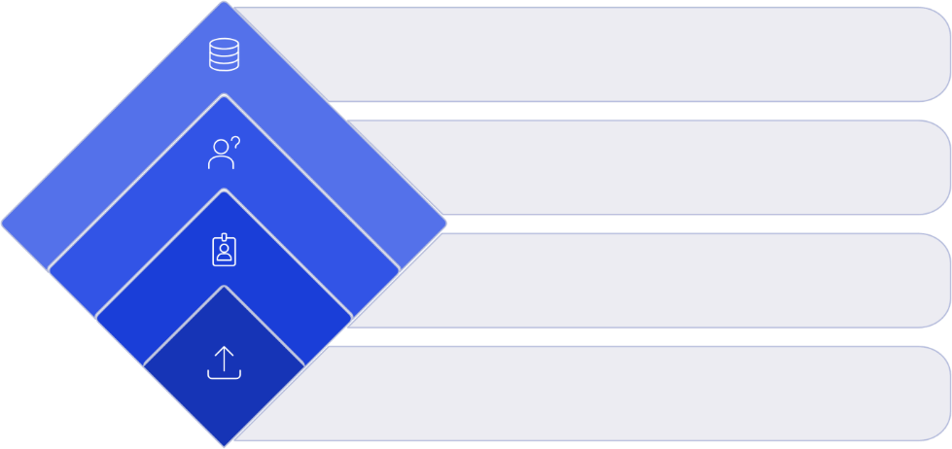

Planning
Establish duplicate prevention logic and decisions at transformation time.

- Assume repeated imports of similar data; use Coalesce to prevent duplicates.
- Set Employee ID as the Coalesce field to identify existing records.
- Behavior: existing Employee ID → Update existing record; new Employee ID → Insert new record.
- Plan to review transformation history and sample records to verify Coalesce results.

Receive employee data






Define test scenarios, expected outcomes, and the validation checklist to confirm correctness.

- Test the initial import and verify records in Employee Test.
- Scenario documented: upload 4 rows — 2 new Employee IDs, 2 existing IDs with changed data.
- Expected first run: 2 Inserted, 2 Updated. Repeating same spreadsheet: 0 Inserted, 0 Updated, 4 Ignored.
- Validate inserted and updated results, review transformation history, and confirm no duplicates exist in Employee Test.
- Verify that the uploaded spreadsheet contains the required five fields before starting the import.
- Confirm that the Employee Import table receives the uploaded spreadsheet data correctly.
- Check that the Transform Map uses the correct source table and target table.
- Verify that each source field is mapped to the corresponding target field.
- Test whether new Employee IDs create new records in the Employee Test table.
- Test whether existing Employee IDs update the existing employee records instead of creating duplicates.
- Verify that changed Employee Name and Email values are updated correctly for existing IDs.
- Review the Transform History to confirm the number of inserted, updated, and ignored records.
- Re-import the same spreadsheet and verify that previously processed records are ignored.
- Perform a final validation of the Employee Test table to confirm the imported data and duplicate-prevention behavior are correct.

Employee Test

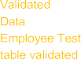

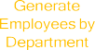




Plan the reports and dashboard that will provide insights from the Employee Test table.

- Report 1 — Employees by Department: Source = Employee Test, Type = Pie Chart, Group by Department, Aggregation = Count.
- Report 2 — Employees by Location: Source = Employee Test, Type = Bar Chart, Group by Location, Aggregation = Count.
- Report 3 — Employee List Report: Source = Employee Test, Type = List with columns Employee ID, Name, Email, Department, Location.
- Dashboard: Employee Analytics Dashboards — include the three reports and configure sharing by Users, Groups, and Roles.
- Plan all reports using the Employee Test table as the report source.
- Ensure the reports use the imported employee records for analysis.
- Plan the Department report to show the distribution of employees across departments.
- Plan the Location report to show the distribution of employees across different locations.
- Use Count aggregation to determine the number of employee records in each group.
- Configure appropriate report formats so the grouped employee data is easy to understand.
- Include important employee fields in the Employee List Report for detailed record viewing.
- Verify that the three reports display the expected Employee Test data after import and transformation.
- Add the completed reports to the Employee Analytics Dashboards dashboard.
- Plan dashboard access by configuring appropriate Users, Groups, and Roles for sharing.

Save

Create Reports







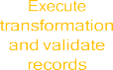


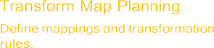

Present the ordered activities required to complete implementation and a concise academic summary of the planning phase.

- Sequence highlights: prepare spreadsheet → create staging and target tables → create and save Transform Map → configure Coalesce → execute transforms → validate and test → create reports
→ assemble dashboard → configure access → final review.
- Planning establishes the structure and sequence needed to implement a repeatable, auditable employee data import process using ServiceNow Import Sets and Transform Maps.

Prepare Data

Test
Tables

Spreadsheet

